Turfcall
www.turfcall.co.uk

Submission

To

The British Horseracing Board Independent Commission

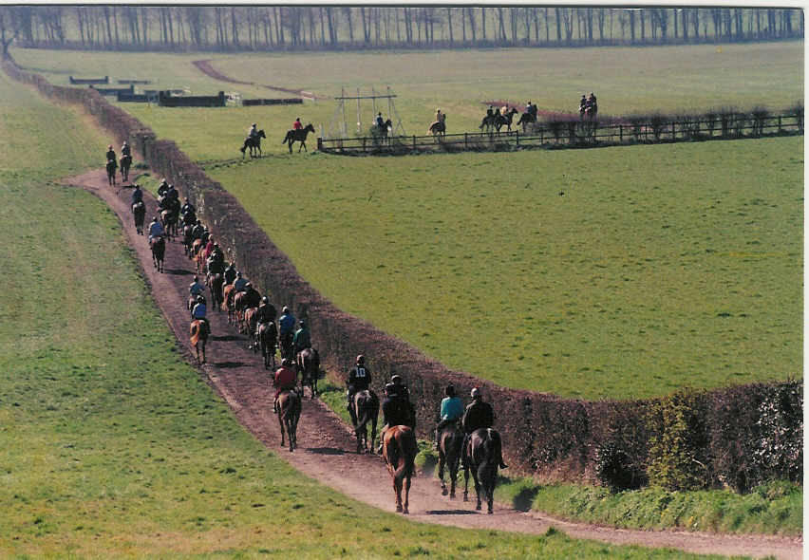

Date: Tuesday September 16th 2003

For the reference of Lord Donoughue
www.turfcall.co.uk
Index Pages

Career Development 1 - 2

Training Personnel Tuition 3 - 4

Employment 5 - 9
Calibre of staff/handlers/riders … page 5
Trainer qualifications … page 5 - 6
The grading of all trainers … page 6
Recognised standards … page 6
Independent financial scrutiny … page 6 - 7
Recognition of professional skills page 7
Distribution of proceeds from
data right sales … page 8
Complexities of skills defined … page 9

Recruitment 10
CAREER DEVELOPMENT DIRECTION:
To establish the ground rules for the future.
All "Handlers/Riders" from the outset to develop their own "Portfolio
of Skill's"
Please note cross references to Turfcall Blueprint 14.2.2001 as stated.
Turfcall Blueprint 14.2.2001 page one.
Turfcall's aim and purpose is to bring "The Back Stage Performers"
directly to centre stage. To uphold all their rights and those of the
beautiful creatures in their care.
The following serious problems are in dire need of change:-
(a) Meagre levels of pay
(b) Scant recognition or reward
(c) In many cases nil to poor accommodation
(d) Long hours and very little time off
(e) Inconsistent levels of training for youngsters starting out
(f) No obvious career development structure
(g) Trainers left to fund the lot whilst other sections of the industry
take all the benefits and cream off most of the profits
(h) All skilled work riders, yearling and two year old handlers and riders at the top of their profession, at present seriously overworked, and grossly
underpaid, unrecognised in the main for most of their fantastic achievements.
Now in an ever decreasing minority. To ask them further to take the learners under their wing allotted to the trainers teams forwork experience, must surely be not only unacceptable, but grossly unfair to all parties.
CAREER DEVELOPMENT DIRECTION:
[a] Each person entering or engaged in this industry to develop from the
outset their very own "Portfolio of Skills."

[b] From the outset a clear structured career path of documented exam
achievements should be provided to all interested parties who are
looking to make this their career.

[c] Accurate information as to wage structures applicable to each exam
achievement to be clearly stated.

[d] Accurate information in relation to learning time scale structures as
applicable to be clearly stated.

[e] Ensuring that each applicant is given the chance to plan their career
structure aims to their best advantage. With the provision of an effective
help line to turn to when required.

Turfcall Blueprint 14.2.2001 Ref: Page 7. Andy Cook head lad for Micky Hammond quote "When lads come into the sport there is no one really to advise them".
TRAINING FOCUS TUITION DIRECTION:
Cross ref: Turfcall 14.2.2001 page two.
Here where Man and Beast compete as one. In all the preparation's for
the track, and in competition on the track. The wellbeing needs of both
must be fairly upheld at all times. Monty Roberts, who was introduced
to Britain by The Queen, has made fantastic strides world wide in
addressing the true balance of understanding between horse and man
to eradicate fear cruelty and ignorance. Providing a clear and wonderful
insight through his books, his documentary films and his actual
demonstrations. Showing how wonderful the true partnership between
man and beast can and should always aim to be.

This unique partnership when equally shared is a fantastic work of art
achievement at the highest level. Could this become the eighth wonder
of the world during this new millennium ? Many more documentary
films of this sort are urgently needed in this country and throughout the world of horseracing to heighten awareness to others whose lives are touched by these beautiful creatures and indeed the rights of all living creatures.

Turfcall defines the two disciplines Fettered and Unfettered.
To cut out all brute force and ignorance using heavy fines and stricter
monitoring practices to address fully all accidents injuries and deaths
to both horses and personnel. To tackle and stop practices exposed
by Monty Roberts in his Blushing E.T documentary. eg. Who was
responsible for the cruel state Blushing E.T. had been reduced to
and suffered ? Matters such as these need a full time investigative
professional team of top horsemen / horsewomen to get matters of
this nature sorted out. Those responsible sent for re-training and
correction.
If thoroughbred racehorses are to be able to reach their true potential
they need to be nurtured and cared for by skilled personnel who know
what they are doing as true horsemen or horsewomen then and only then
are they spared from the abuse suffering and pain of ignorance that blight
and waist their lives. Awareness at this level now needs to be structured to ensure that this is fully understood, realised and respected with ncentive and recognition to uphold. A thorough 5 year training program from the outset, with further structured specialist tutorials/ courses thereafter.
TRAINING FOCUS TUITION DIRECTION:
Cross ref: Turfcall 14.2.2001 page three.
[a] To set up a nationwide area of universities.
[b] To tackle the suggested five year learner/student/apprentice program
structure.
[c] To tackle the suggested follow up six to ten year further education
specialist courses.
[d] To tackle and structure adult education courses.
Cross ref: Turfcall 14.2.2001 page four.
[e] To run a points system for each member of each trainers team to embrace
riding ability on various specific counts, to work in conjunction with [a].
[f] To set up condition races open to handler/riders in the one to five year
category.
[g] To set up condition races open to handler/riders in the six to ten year
category.
EMPLOYMENT DIRECTION:
Establishing the ground rules for the future.
All "Handlers/Riders" from their commencement should be encouraged
to develop their very own "Portfolio of Skill's" .
Please note cross references are made here to Turfcall Blueprint 14.2.2001.
CALIBRE OF STAFF.
The Burnham Report suggestions that superstore shelf stackers could work part time for trainers being paid at the Governments minimum wage.
[a] Will owners be satisfied with this unskilled cheap option for their high
priced thoroughbred bloodstock ?
[b] Who do the owners want to tutor and care for their racehorses whilst in training ?
[c] Where does the element of safety considerations for both the animal and the personnel come in, in the Burnham Report suggestions ?
Note
[d] What do the owners think of this Burnham Report suggestion ?
[e] What do the trainers think of this Burnham Report suggestion ?
[f] What do the jockeys think of this Burnham Report suggestion ?
TRAINER QUALIFICATIONS.
In relation to a NEW Jockey Club Licensing Department.
[a] Trainers need to be assessed and licensed as to their ability to
train thoroughbred horses.
[b] Trainers also need to be assessed on the quality and number of
professional handler/riders they employ to make up their teams.
[c] Trainers are there to train the horses, and to do that professionally
they need to be able to employ handler/riders of the highest professional
calibre, as in Status Grade A.
[d] Trainers need to be able to pay a decent and fair wage if they are to be
able to form a team with the right creditentials to carry out this work to a
reasonable and acceptable standard.
[e] Trainers cannot carry out their duties in an efficient, fair and
reasonable manner to either the horses their owners or their team members if they do
not have the highly skilled back up support of professional handler/riders
of a Grade A status. There are no cheap short cuts in this department.
THE GRADING OF ALL TRAINERS
By a NEW Jockey Club Licensing Department.
[a] According to the quality of handler/riders they choose to employ.
[b] According to the hourly remuneration they are prepared to pay.
RECOGNISED STANDARD
The professional graded status of each handler/rider.
[a] The professional graded status of each handler/rider according to
their ability achievements gauged against a NEW set of recognised
national standards.

INDIPENDENT FINANCIAL SCRUTINY
A remuneration framework based on establishing a recognised "Portfolio of
Skills" that can be independently assessed.
[a] To implement such a framework it will be necessary to establish an
independent payment structure guided by knowledgeable (eg retired)
professional horsemen and horsewomen who have no conflicts of interest.
[b] Within the New proposed remuneration framework, should be directly linked to each handler/rider's achievement detail, and their proposed career development direction.
Turfcall has in the past proposed a remuneration framework based on
establishing recognised Skills Level that can be independently assessed .
Within the proposed remuneration structure, the hourly rate would be directly linked to the "Standard of Skills" of each Handler/Rider.
RECOGNITION OF PROFESSIONAL SKILLS
Turfcall draws attention to the Definition of a True Professional Grade A
Status Handler/Rider.
[a] Only by ensuring that there is an adequate reward for performance at
the top end of the skill range is it possible to establish a career structure.
[b] For example, on Wednesday August 20th 2003 at the Ebor Meeting at York we saw the 2-y-o colt Balmont win the Gimcrack with the professional handler/rider David Goodwin in his rightful place presenting Balmont to the public.

[c] David Goodwin is a true professional Grade A status handler/rider of the highest calibre.
[d] Is the BHB Independent Commission able to quantify what David's
skills actually are ?
[e] Is the BHB Independent Commission able to quantify what hourly rate of pay they think should be applicable in the future for such professional skills ?
[f ] The Turfcall proposal points out why the hourly remuneration for the
professional skills of personnel such as these, need to be brought out in the open. To raise awareness, and to ensure for the future that there is a far better understanding of what this is actually all about.
[g] Unless the top professional Grade A Status personnel are recognised in full and paid for their skill and art the whole present Grading Status
structure is worthless.
[h] At present the 70p per hour minimum as set by the SLA and the NTF above the Governments minimum wage rate for student/learner handler/riders, for such professional skills can only be classed as gross theft or daylight robbery and at least gross ignorance.

DISTRIBUTION OF PROCEEDS FROM DATA RIGHT SALES
Turfcall calls into question the distribution of funds arising from Data
Right Sales, including pictures, television and daily race cards both at the
racecourses and for the media via newspapers etc.
[a] The personnel who tutor nurture and care for each horse daily, those who do take all the risks, and can either make or break these beautiful young creatures lives should be recognised and supported with full financial reward not peanuts in their chosen career.
8.
[b] A proportion of the monies earned by Data Right Sales, should belong to them, and should not be taken by others under false pretences. By supplementing the wages paid by Trainers a wage equal to skill could be attained.
COMPLEXITIES OF SKILLS DEFINED
Turfcall draws attention to the definition of a true professional Grade A
status handler/rider.
[a] Only by ensuring that there is adequate reward for performance at the
top end of the skill range is it possible to establish a career structure.
[b] The example given above, of David Goodwin and the 2-y-o colt Balmont achieving success to win the Gimcrack at the recent York Ebor meeting, is the result of the daily skills carried out by David with Balmont over months of patience tuition and dedicated care and true understanding of an animals needs.
[c] Turfcall takes the view that the hourly rate for such skills should be
in the region of £25.00 per hour, including all work carried out on a
racecourse, plus travelling to and from a racecourse.
[d] In Turfcall's view this remuneration should be met in part by the
racecourse and paid directly to David Goodwin before he leaves the racecourse.
RECRUITMENT DIRECTION:
[a] To allow people perspective to view and buy into a lifestyle.

[b] To allow all tutorial career opportunities the true essence within
horseracing itself … a value, money remuneration for each stepping stone
status achieved to aim for the top.

[c] Remuneration to come out in the open according to NEW Professional Graded Status achievements.

[d] The future of recruitment in horseracing is totally dependant on
the future that horseracing can offer.

